SURROUNDED BY EMOTIONS

Trigger warning/sensitive content warning: may contain themes surrounding cyber bullying, online toxicity

Originally designed 2019 by Swedish larp designers [Karin Johansson](https://www.katalog.uu.se/profile/?id=N19-96) and [Jon Back](https://www.katalog.uu.se/empinfo/?id=N13-749), Uppsala University. Adapted for the workshop edu-larp@CHI 2023.

# Description

### Story

In the near future, people try to relate to emotional social media, and to each other. Some are less successful and these are now voluntarily (?) recruited for IRL training, at an IRL retreat camp. How should they relate to the feelings they carry inside and outside of them?

The larp takes place story-wise in the near future where participants must detox themselves off social media, and get help to relate to their off-screen emotions, without emojis. To help them they get to use the Emotio-meters, a wearable that shows their emotion through colored lights.

### About the larp concept

The larp is set in a near future at a social media retreat camp. In tonality the larp leans towards silly/satirical but with possibilities for more deep reflections also. The Characters in the larp use a device that shows their emotions as color coded wearable lights. The dynamics of the larp is based on the participants relating to their own and others' feelings, both those that shine from the used wearables and the feelings they try to manifest in speech and body language.

# Target group/Age group

The larp is mainly designed for adults/professionals. The larp in this version is meant to be used as a part of a larger edu-larp workshop.

# Number of participants

8-18 people. (more if the same role is used multiple times, which is possible)

# Number of facilitators

At least 2 game leaders.

# Goal and Purpose

To explore the possibility of using technology augmentation to explore emotions and others' perception and preconceptions about your emotions. Designing a lab that tests new technology.

Explore wearing emotions on the outside and exposing personality to public view in a thought-provoking technology-enhanced experience.

Finding new ways to tech-enhance lives to make them more interesting. Broadening how technology can be used to create interaction and experiences that are not based on gamification. A short larp experience aimed at trying out how larps can be used for futuring and as a starting point for speculative design discussions.

# Materials and needed pre-conditions

* A room where the lights can be turned off/tuned down
* Wearable Tea lights (with remote controlled color change). 1 for each participant.
* 1-2 remotes for the tea lights
* Printed roles
* Large poster/s with colors/feelings legend
* Preferable a space for writing (for instance a whiteboard) and pens
* Pens and papers
* Optional: some costumes and accessories
* Optional: Sound system with relaxation music
* Optional: printed out Quiz walk (and tape can be useful for putting those up)

# Preparations

* Print out roles, cut them apart
* Print out poster or write on whiteboard the colors/feelings legend
* Prepare a table with the tea lights/emotio-meters (make sure they work and have batteries)
* Hide the remotes (for instance in the pockets of the facilitators)
* Prepare a table with costumes and accessories (if those will be used)
* Prepare the loudspeaker (if this will be used)
* Print out Quiz walk (this can be put up in-game by a facilitator)

# Roles

The role handouts are found as an appendix in this document. You can also find it in the separate document:

<https://docs.google.com/document/d/1IJfmLkjDW_VKOiVSwqIlVKrAah56xbsSCLui0b1w28Y/edit#>

Short list of Roles:

1. The Troll (Flashback, fb,4chan)
2. Like-junky (fb, insta)
3. Selfie-slave (Insta, snap)
4. Foodie (Insta)
5. Influencers (multi platform, youtube)
6. Pro networker (linked-in)
7. LoveFool
8. Expert geek (closed groups on fb, youtube)
9. The consumer/reader (fb)
10. The gamer (mmorpg)
11. The One with Opinions (Twitter, comment field)
12. The online Stalker (fb, insta)
13. cOnsp1racy_nut (fb, flashback)
14. embarassing_parent (fb)
15. The Meme producer (fb)
16. The celebrity follower (insta, fb)
17. The cat movie lover
18. The Online_philosopher

NPCs:

* Facilitators
* Doing their job at the IRL retreat camp (rather bored about it)
* Secretly very addicted to social media
* (OFF-GAME INSTRUCTIONS: NPC also handle the remotes for the tea lights, this is important for steering the larp)

# 

# SURROUNDED BY EMOTIONS: GAMEPLAY

# Introduction before starting the game (10 min)

Hello and welcome

(are any folks colorblind?)

## Off-game intro talk

Practical

* We will play in this room for a short while (we tell you when the larp starts and when it is over.
* If you need to talk off game, approach one of us organizers (and start your sentence with: off-game…). Or leave the room.

About the larp

* This larp takes place in a not so distant future
* All characters are heavily addicted to social media (as is most of society)
  + You are not used to, and nervous about, meeting people IRL
  + You probably do your shopping online, hang out online, study/work online and so on
* You are all now attending the "IRL retreat-camp", where your roles will practice meeting people IRL. In the glossy folder it is presented as a high-tech tech-detox camp, and seems very impressive.
  + Your cellphones have been confiscated. You have no wi-fi here at the camp.
* When the larp start you have just been handed your Emotion-Devices: The emotio-meters. They are said to help you reconnect to IRL-emotions and understand other emotions.
  + Your characters have never seen one of those gadgets before.
  + No one has explained how they actually work, but they seem very tech savvy.
* Meta rules
  + You act upon/react on the feelings given by the emotion-device

The meta-techniques are introduced. The participants get to try out their devices and learn the emotional colors.

Hand out characters (suggestion: randomized). Make sure everyone understands their character. Let everyone just very shortly think about their characters (age, occupation, life).

Optional: Let everyone choose some costumes and/or accessories.

Let them gather in a group and start the larp. Ask if anyone has any final questions. Suggestion: start the larp by letting everyone close their eyes and count down from 5 to one.

# In Game: Sequence of events (tot 25-35 min)

(OFF-GAME INSTRUCTIONS: during the whole larp the facilitators voices that they are very understanding, empathic. But they are really bad at facilitating, also they use their phones all the time so they hardly look at the participants during the sessions and radiate dis-interest and double standards)

## Introduction in-game (5 min)

It begins with a large gathering where participants are welcomed to this social media addiction bootcamp. The facilitators of the camp emphasizes that this is hard, to meet IRL, that you are all not used to this, and that everyone must focus on collaboration and helping each other.

NPC says: *This clinic is specialized on detoxing social media addiction. Our methods are based on clinical studies. You probably recognize us from the e-book and the TickTock phenomenon Surrounded by Emotions. We look forward to guiding you through todays session.*

### Introduce the Fake-Phone opt-out

The facilitator tells everyone that their phones have been confiscated, and shows them the cardboard/atrap fake-phone, that can be used by participants if they need to opt out a short while from the IRL pressure.

### Introduce The wall

The facilitator shows the Feed wall and tells that it is possible to write comments and write down your thoughts. If it feels awkward that people can't see your thoughts, and that you cant post stuff.

### Participants get their devices

NPC: *You will be helped to manage your emotions with our scientifically proven emotio-meter.*

Emotional colors:

Red = angry - dominant/gets straight to the point

Green = concern - caring/good listener

Blue = Sorry - looking for answers

Yellow = joy - cooperative/likes to have fun

**Talk about emotions and the emotio-meter**

The facilitator holds a short talk (Note to NPC: improvise from this suggestion):

*You are all Disconnected from your emotions- Alienated, emotionally numbed. Now it is important for you to be here in the room, to experience embodied mindfulness. Feel your feelings and sense what others feel. This is hard.*

*For that you will get some help in the form of these devices. Developed to provide a close connection with your feelings and so that you do not have to guess what others are feeling. They measure your emotions through advanced technology. This will help you make true friends, real friends in the real world. This first session is about Empathy. Understand others and don't just focus on yourself.*

[hand out emotio-meters to everyone. Make sure they work.]

Tell them that these show your feelings.

## Workshop 1: Values ​​exercises (10 min)

NPC: Now we shall learn to connect with our emotions through the emotio-meter.

**Quadrilateral exercise:** A feeling is specified for each corner of the room. Participants are told to follow their feelings and choose corner.

(OFF-GAME INSTRUCTIONS: here facilitators discretely play around with changing colours with the remote, so that people will have to react to the feelings showing. Use one or several of the corner exercises below, depending on available time and so on)

I am:

* Glad
* Angry
* Sorry
* Worried

Discuss in your corner: Why do you feel like this?

I'm on social media to:

* Watch/make Movie Clips
* Read
* Write
* Answer

Discuss in your corner: what do you feel about social media?

When I act on social media, it makes me:

* Satisfied
* Angry
* Upset
* Indifferent

Discuss in your corner: why does social media make you feel like that?

When I think about the day today, I feel:

* Expectant
* Happy
* Satisfied
* Delighted

Discuss in your corner, why does this camp make you feel like this?

**Line excercise:** participants form a line along the floor for each claim, from totally agree to totally disagree.

Claims:

* I am often on social media
* I post more than I read
* Being on social media makes me happy
* I often get a lot of likes on what I post

Discuss for each claim with people standing close to you.

(OFF-GAME INSTRUCTIONS: Skip this if time is short)  
here facilitators discretely play around with changing colours with the remote, so that people will have to react to the feelings showing. Use one or several of the corner exercises below, depending on available time and so on)

## Workshop 2 - putting emotions into words (5 min)

Step 1: Walk around the room. When you meet someone, say hello and ask each other how you feel. Answer the other person's questions.

Step 2: Walk around the room. When you meet someone, say hello and ask each other how you feel. Answer the other person's questions. Then try (if you want to) to ask why, or ask another question.

## Workshop 3 - Question Challenge (5-10 min)

Divided into groups

Answer the questions in the group. You must agree on the answer. Nice prize for the winner.

Remember to put your and other people's feelings into words during the tips walk.

(OFF-GAME INSTRUCTIONS: here facilitators discretely play around with changing colours with the remote, so that people will have to react to the feelings showing. Use one or several of the corner exercises below, depending on available time and so on)

(The Questions: [Question challenge- surrounded by emotions](https://docs.google.com/document/d/1932ZsIMiW7PSFSDxDauplhAFG2ImbcBlLKBz3wrfyqM/edit#))

OR

## Workshop 3: Group discussion (5-10 min)

The participants sit in groups with a facilitator. In their view on social media, **why** are you on social media etc. Two and two after a while.

It is important that you listen and respond. “Oh so interesting”

(OFF-GAME INSTRUCTIONS: here facilitators discretely play around with changing colours with the remote, so that people will have to react to the feelings showing. Use one or several of the corner exercises below, depending on available time and so on)

## Workshop 4: Relaxation e

## xercise (5 min)

Meditate/sleep. Don't do anything.

Facilitator: Close your Eyes. Don't think about how many likes you usually get. Dont think about how much you miss using your cellphone. Dont think about you online social life. Dont feel the missing weight of your cellphone in your hand, Don't feel for the missing vibrations of your phone in your pocket. Be in this moment.

(OFF-GAME INSTRUCTIONS: Supposed to be a super short, really crapy meditation (Dont think of a pink elephant…))

* End with: Larp is over!

# After the larp - debrief (10 min)

After the session, everyone hands back the emotio-meters. Then a debrief is held as well as a little conversation about the method used and the technique reinforcement.

A few things that could be interesting to bring up:

* general/spontaneous reflections from participants
* How did it feel to larp this larp?
* That this larp was originally written before the pandemic (what has changed?)
* How did you as a player/your character interpret the tech?
* How could this be used in speculative design exercise

## 

## HANDOUT: ROLES



## The Internet Troll (Flashback, fb, 4chan)

**(Nick)name:** Troll

**Short description:**

Trolls all discussions. Some call the Troll a saboteur and a social danger. The troll ignores this.

## 

## 

## The Like-junky (fb, insta)

**(Nick)name:** Likey

**Short description:**

looooove getting likes. Has a life crisis if too few people liked the last post.

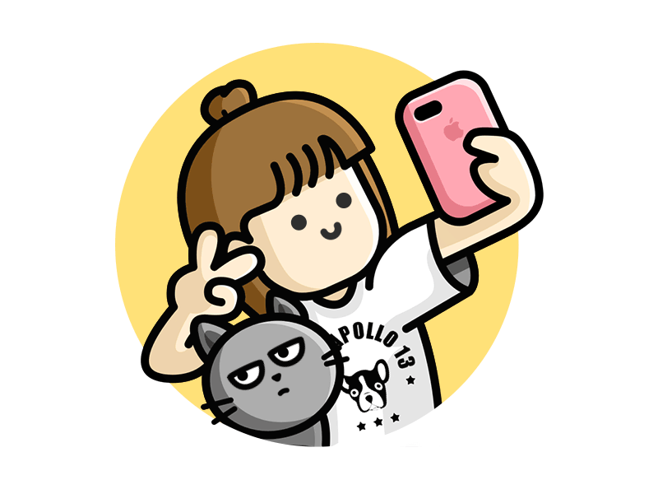

## The Selfie-Slave (Insta, snap)

**(Nick)name:** LookatMe

**Short description:**

I have ten thousand pictures of myself on my phone. The search for the perfect angle is eternal.

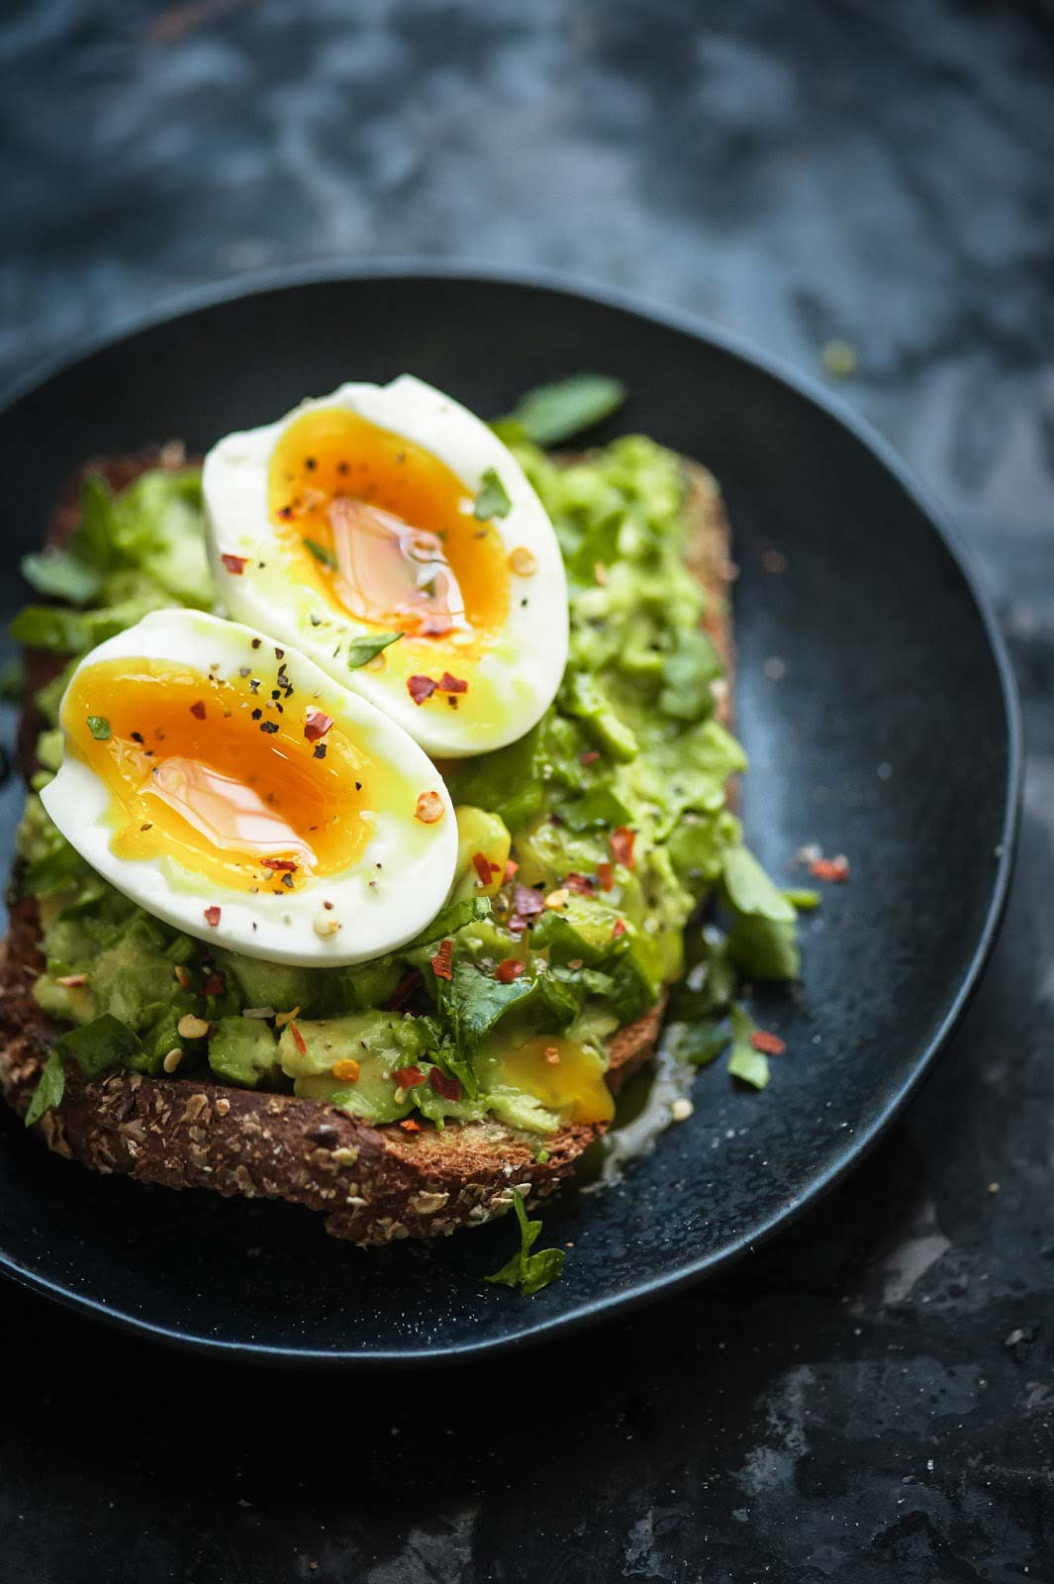

## The Foodie (Insta)

**(Nick)name:** Foodie

**Short description:**

Everyone is interested in seeing exactly what you had for dinner. A beer reflecting the sunlight is a work of art.

## The Influencer (multi plattform, youtube, ticktock)

**(Nick)name:** Foodie

**Short description:**

It gives a rush of power that people read what you write and that they listen. Even if you say nothing of importance…

## The Pro-Networker (linked-in)

**(Nick)name:** Link

**Short description:**

Networking is the new black. Through your contacts, you will get the perfect job and all doors will open...soon...

## The Love-seeker (tinder)

**(Nick)name:** LoveFool

**Short description:**

Happiness is love, great love awaits and it WILL be found online. Swipe for love!



## The Expert Nerd (fb-groups, youtube)

**(Nick)name:** Techy

**Short description:**

You know everything about your special interest. You love to geek out with others who know just as much. You love even more to complain about idiots who is not knowledgeable enough.

## The Consumer/reader (fb, insta)

**(Nick)name:** Scroll

**Short description:**

Scroll, scroll, scroll! You know everything about everyone but nobody knows anything about you. For some reason you never post yourself, but depend on others to do it!

## The Gamer (mmorpg)

**(Nick)name:** Bomber

**Short description:**

You are loyal to the clan and quest more hours a day than you sleep.

## The one with Opinions (Twitter, comments section)

**(Nick)name:** IMHO

**Short description:**

You have opinions. Strong opinions. About everything. About how things were better when… You are also a friend of order.



## The Online Stalker (fb, insta)

**(Nick)name:** n0n0wYRbznz

**Short description:**

You check everything about people who are close to you. Or people you met once in a while. What do they earn, what do they eat, what are their opinions? You can find out EVERYTHING!

## cOnsp1racy_nut (fb, flashback)

**(Nick)name:** InsideJob

**Short description:**

Chemtrails, Flat earth, Atlantis, spaghetti monsters... The big truths are silenced. But you are a champion of the truth!

## Embarrassing_Parent (fb)

**(Nick)name:** Gran

**Short description:**

Pictures of the grandchildren and reels (those new cool mini-videos!) from the holiday, ohlala. You are not very technical and can barely send an SMS. It often gets tricky when you try to be digital. But that doesn't stop you from trying and from spending all your time communicating digitally with old friends and the extended family. And you have just discovered the potential of Emojiiiiis!

## The Meme Producer (fb, insta, messanger)

**(Nick)name:** Meme

**Short description:**

* 1. Nailed it! The Internet is FUN! You spread joy in a wonderful way, in your own opinion!

## 

## 

## The Celebrity follower (insta, fb, ticktock)

**(Nick)name:** CelebFriend

**Short description:**

What kind of toothbrush does Pim Pardashian have? Everyone knows that! You love to read about and write about the lives of famous people. They are so interesting!

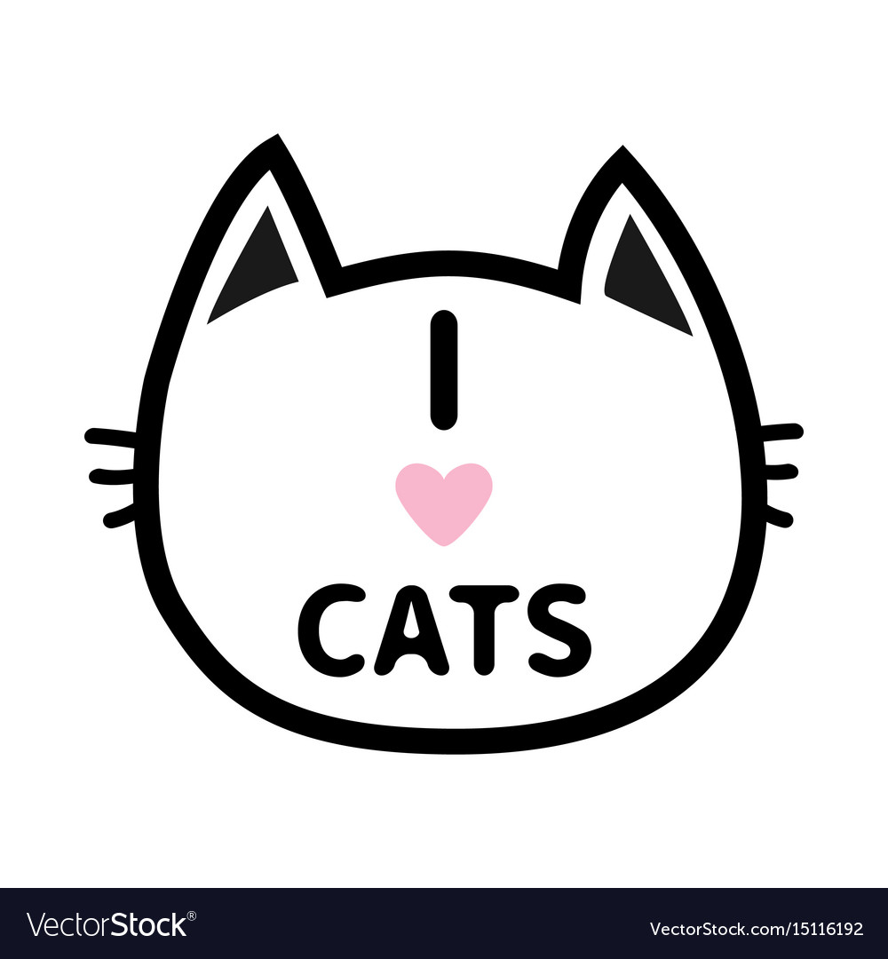

## I <3 CATS (insta, ticktock)

**(Nick)name:** CatLover

**Short description:**

When life is hard, a cat movie or other cute animals is your beacon in the dark. If everyone only watched cat movies, the world would be a better place.

## Online_Philosofer (multi platform)

**(Nick)name:** CarpeDiem

**Short description:**

To be or not to be? Nothing is what it seems. Carpe diem. You love to spread thoughtful messages and share life wisdom. It makes people grow.

Emotio-meter Color Poster



RED = Angry. Dominant/ Gets straight to the point



GREEN = Concern - Caring/ Good listener



BLUE = Sorry - Looking for answers



YELLOW = Joy - Cooperative/ Likes to have fun

Question 1: Outdoors

Outdoors there is a risk that the screen will be dazzled by the bright light. But if you try to look up from the screen, you can see exciting things.

**QUESTION**

What is it that causes the bright light outdoors?

1. Huge LED-lamps

X. My Eyes

2. The Sun

Question 2: History

There was a time before the internet. There is even a time before the computer. The Arpanet was a precursor to the Internet.

**QUESTION**

What year was Arpanet launched?

1. 1796

X. 1967

2. 1969

Question 3: Culture and Entertainment

Pim Pardashian has a lot of followers. Many are interested in her life. Recently, she acquired a new hygiene item that got a lot of attention on social media.

**QUESTION**

Vilken hygiene item did Pim Pardashian buy recently?

1. A New body lotion

X. A New toothbrush

2. A New Hairbrush

Knockout Question:  
  
Name at least 3 ways to hang out and socialize without using technology!